This Photo by Unknown Author is licensed under CC BY-SA
Here are some ideas for helping your child to improve the size and form of letters and words when they write:

- We recommend a short daily practice of around 10 minutes – happy repetition helps good habits embed and become natural

- Use a highlighted line to write on so you can see if the letters are the right size compared to each other

- At first use a narrow pencil to check there is enough space between letters or words

- Revise lower case letters first, practising one letter family at a time
  - These letters start like c c o a d q g

  - These letters start like r r n m h k b p

  - These letters are similar i l t c j f

  - These letters are similar v w u y

  - These are the ‘extras’ eszx

- Next revise capital letters

- A good way to practice mixing lower and upper case letters is to write names lists in alphabetical order e.g. children’s names, countries, animals, Star Wars characters etc

- Progress to writing or copying out short sentences

- Make practice fun to keep your child motivated – use things that interest them such as cartoon or film characters, copying jokes or rhymes or limericks

- Encourage your child to pick out a ‘letter or word of the day’, the one they feel proudest of

- In time you can stop using both the spacer and the highlighted line

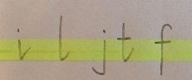
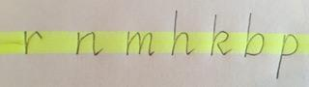
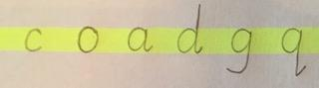

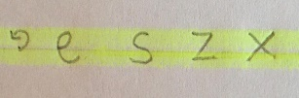
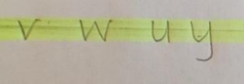

You can watch the video of these ideas here: (insert link)???

