Websites for New Arrivals 3
ICT Games

www.ictgames.com

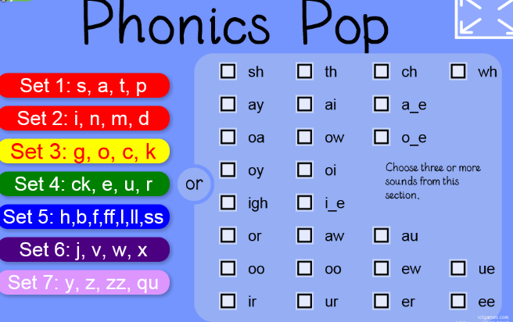
- Phonics Pop is a mobile friendly bubble pop game. Choose a set of sounds to practice, or select from the digraph (2/3-letter sounds) checkboxes. Then listen to the target sound and pop as many as you can. If the child achieves >95% accuracy the bubbles will change to rainbow colours.
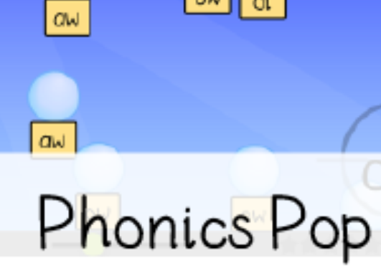

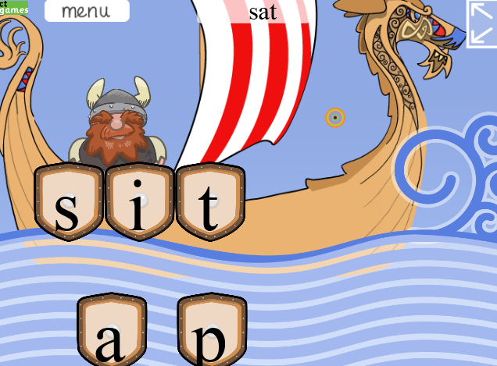
- Viking Full Circle uses sets of letter sounds chosen from different sets. The child changes one sound each time to make the next word. The child shouts “full circle” when they’re back to the word from the beginning.

Listen to the word that you need to spell.
Arrange the sounds on the boat to spell the word, (why not give the rest of the class dry-
wipe boards so that all can take part).
Press on the big wave to see if you're right.
If you're wrong the Viking will look down at what you've done, if you're right he'll cheer.
The first word is displayed throughout the game. When you find the first word again shout
'Full Circle'.
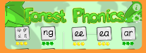

- Forest Phonics

Choose a spelling pattern and you will be prompted to spell approximately ten words using that spelling pattern, e.g. 'ay' words.

Click on the snail. If no word is said then click on the to hear the word.

The sounds are easy to move around using the drag and drop sound cards.
Each correct answer is rewarded with a funny animation.

If you need help you can hear the word again by pressing

Or take a quick peek at how to correctly spell the word by pressing

A simple scoring system lets you know how well you've done.
The game covers 30 spelling patterns.

These are only a few of the games on the site but I thought these ones might be most useful for the newly arrived children who have little or no English.

Mrs Veronica Callaghan
EAL Service
vcallaghan@sandwoodlcr-pri.glasgow.sch.uk

