Websites for New Arrivals 1
Games To Learn English
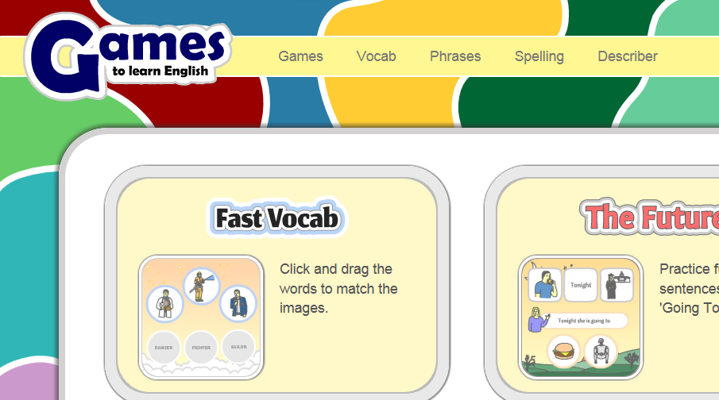
www.gamestolearnenglish.com

These are simple games for learning basic English vocabulary. Primarily, it is aimed at EAL (English as an additional language) learners, but other learners may find it useful too. To play, just listen to the words and click on the matching images. The game gets faster as you progress and if you do not click quickly enough, then the game will end. You can choose which vocabulary to practice by clicking on a set in the content screen. There are about 30 sets of content that cover most of the basic vocabulary items/survival language areas.

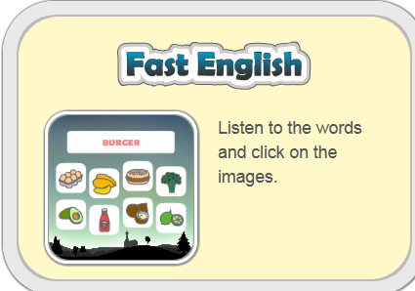
- Choose a speed. → choose a category →ie animals

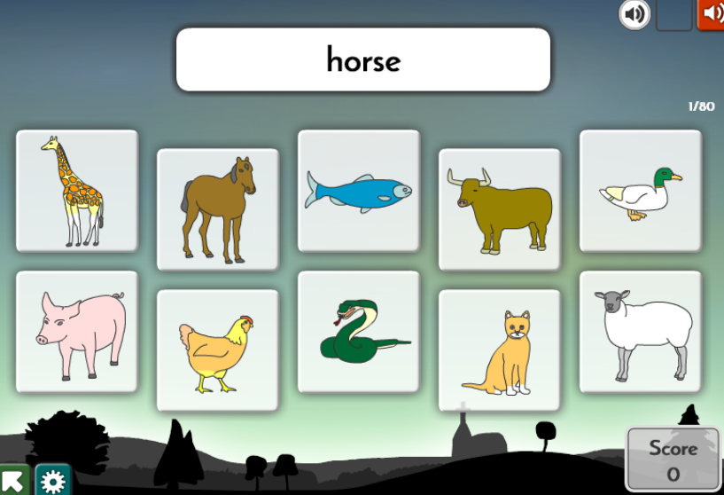
Click the correct animal picture. If it is wrong it disappears. Keep clicking until only the correct picture is left.

Click the to hear the word.

- Read the sentences and move the clothes.
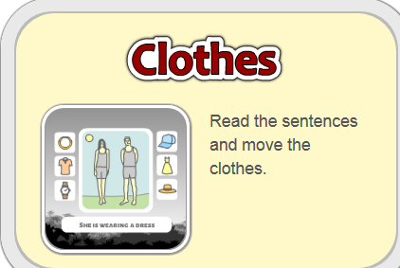
Can select different categories: winter, summer,
spring, autumn, formal, student, casual and beach.

Use arrow under the word play.

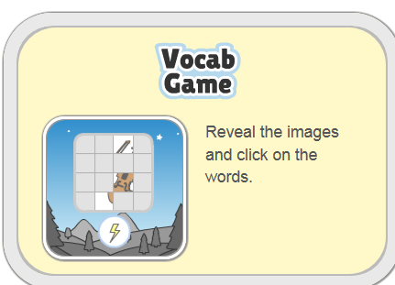
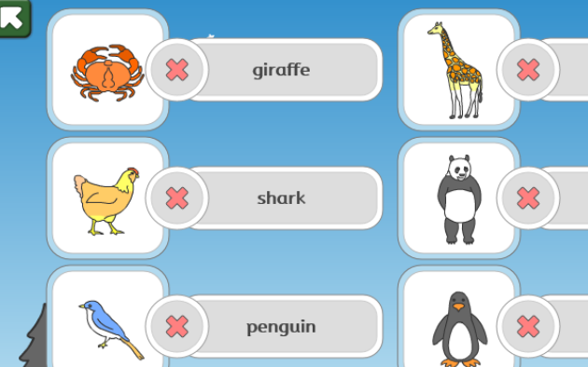
Choose a category
→Match words to animals


When all correctly matched a grid appears. Click to reveal part of picture. When you think you know what picture is then
click the word.
If you do not know then keep clicking until all of picture is revealed.


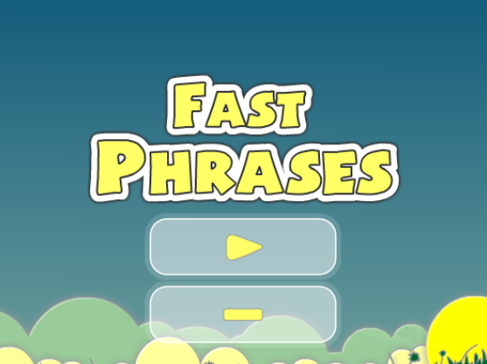

You can choose from: verbs, likes, places, position, time and more.
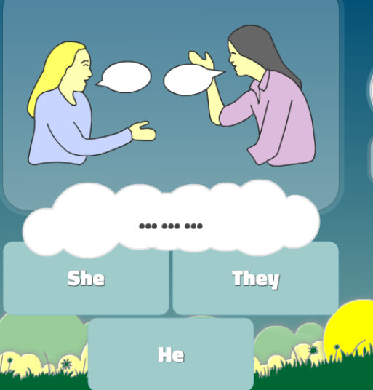
The sentence is split into words. Click on the correct word from the choices. If wrong try again. When correct the next word for the sentence will appear. The full sentence is read at the end.

These are only a few of the games on the site but I thought these ones might be most useful for the newly arrived children who have little or no English.

Mrs Veronica Callaghan
EAL Service
vcallaghan@sandwoodlcr-pri.glasgow.sch.uk

