Websites for New Arrivals 2
Starfall
www.starfall.com
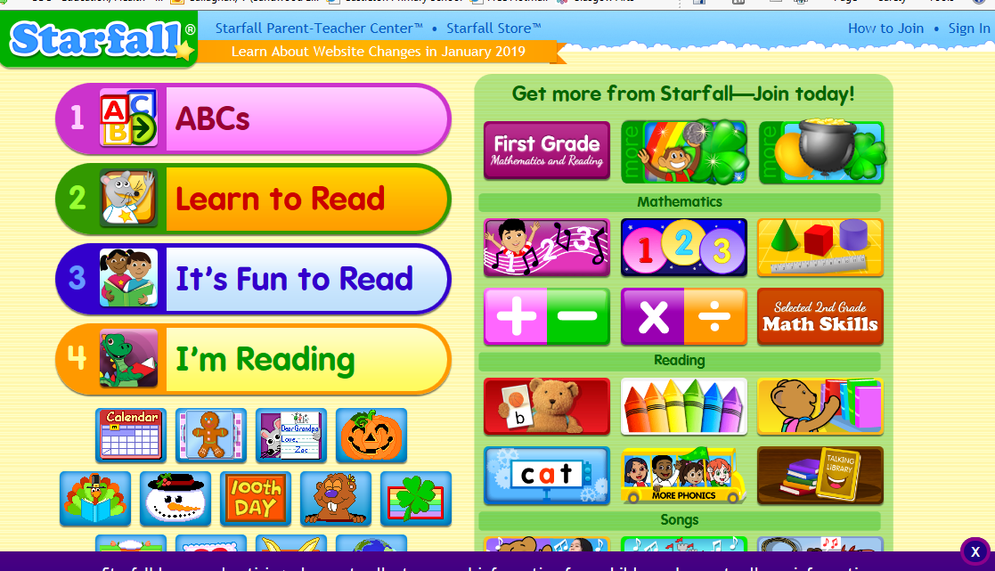

- For audio books:
Click talking library (circled icon above)
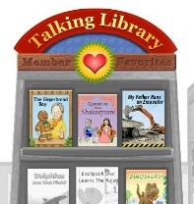
Click on a book and listen to the story. The spoken sentences are highlighted when being read.
When the entire page has been read, the child can click on individual words to
hear them.
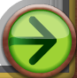
Click this arrow to continue to next page.

Click this arrow to return to main page.

- Two books “AComputer” and “At School” give basic sentences.
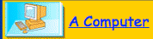
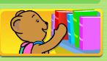
Click Click

The computer book is good as it names associated objects ie mouse, keyboard etc.
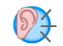
Click to hear sentence. Child can then click on individual word to hear them.

- Making very basic sentences for computer and at school.
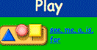
Click

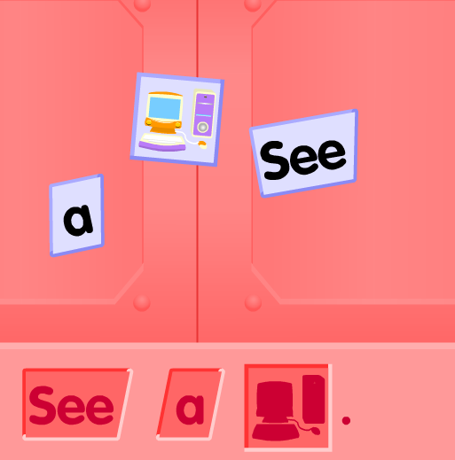
Child clicks and drags words onto sentence at bottom.
Individual words are read and then whole sentence spoken.

- Make a word. Covers CVC words. ( an words, at words, et words etc)
Click this arrow to return to main page.
Click 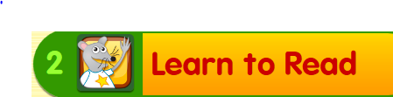
Click 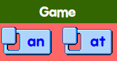 Click on the ‘an’ or ‘at’.
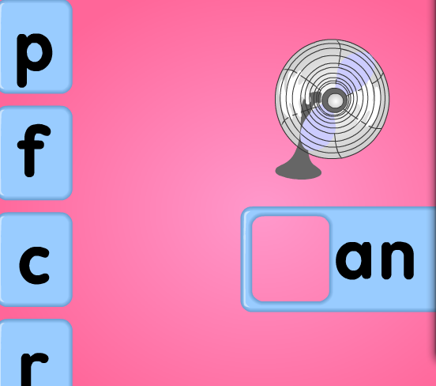
Child has to click and drag the correct initial sound to make the word.
Continue until all 4 words are made.
A list is then produced and child can select each word to hear it again.
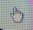
You need to make sure that you have the hand icon to click on the word to be spoken.

These are only a few of the games on the site but I thought these ones might be most useful for the newly arrived children who have little or no English.

Mrs Veronica Callaghan
EAL Service
vcallaghan@sandwoodlcr-pri.glasgow.sch.uk

