Using Playing Cards to
Support Numeracy

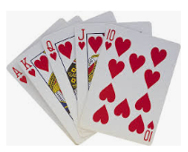

Why Play Card Games?

- Builds number sense and confidence
- Supports memory providing overlearning opportunities
- Can be used alongside concrete-pictorial-abstract approaches
- Experiential, active learning
- Encourages fluency and can help develop thinking skills
- Alternative strategy for learning number facts and times tables
- Provides number talk opportunities
- Reinforces the language of maths and can support EAL learners
- Appropriate for all ages and stages
- Encourages risk taking, turn taking and social skills
- Behaviour management
- Intergenerational
- Can help with maths anxiety
- Inexpensive
- It is fun!
Suggestions for Incorporating Card Games
Maths Lessons
Homework
After School Club
Maths Lunch Club
Family Learning/Parent Workshop
Choosing Tuesdays/Wednesday Wonder Class/Golden Time
Wet Play Activity
Familiarisation Activities

Children can sort:
- Suit
- Colour
- Odd and even numbers
- Numbers bigger than 5 and less than 5
- Order cards from Ace to 10/have a missing card
Memory games: 4 cards are put out, hidden, then 1 is removed, child says which card has been removed (can have more or less cards to start with).
Subitising: Numbers are cut off cards to play snap, higher or lower, number battle etc.
Higher or lower
No of Children: 2
Cards Required/Resources: Ace to 10 for each child. Face cards removed.
Instructions:
- Each child gets a set of cards Ace through 10 i.e Ace, 2,3,4,5,6,7,8,9 and 10.
- Player 1 selects a “secret card” from his/her hand and places it face down.
- Player 2 tries to guess what the number on the card is by selecting a card from his/her hand and placing it face up.
- Player 1 then tells whether the secret card is higher than or lower than the face –up card. Player 2 continues to make guesses by selecting and showing different cards until he/she has discovered the value of the secret card.
- Players then switch roles.
Number Battle

No. of Children: 2
Cards Required/Resources: Deck of Cards. Face cards removed. Ace card included as 1.
Instructions:
- Players split a deck of cards and simultaneously flip over their top cards.
- The higher value card wins the pair.
- If the cards have the same value, each player turns over a new card and the highest value of all the cards wins.

Place Value Number Battle

No. of Children: 2
Cards Required/Resources: Deck of Cards with the face cards and 10s removed. Ace worth 1.
Instructions:
- Players split a deck of cards and simultaneously flip over their top three cards to create a 3-digit number.
- Players can move the cards and place them in any position they wish to create the highest number.
- The highest number wins all six cards.
- You can increase the number of cards to flip if you are working on larger numbers.

Addition Number Battle
No. of Children: 2
Cards Required/Resources: Deck of cards. Face cards removed. Ace worth 1.
Instructions:
- Players split a deck of cards and simultaneously flip over their top two cards each.
- The player with the highest addition calculation wins all four cards.
- If the cards have the same value, the cards are placed in a centre pile.
- The next hand is played normally and the winner of the next addition number battle takes the centre pile as well.
Advanced Addition Number Battle - use 3 or 4 cards. Ace worth 11, Jack worth 12, Queen worth 13 and King worth 14.
Subtraction Number Battle
No of Children: 2
Cards Required/Resources: Deck of Cards. Ace worth 1
Instructions:
- Players split a deck of cards and simultaneously flip over their top two cards and subtract the smaller number from the larger number.
- The greatest difference wins all four cards.
- If the cards differences have the same value, the cards are placed in the centre pile.
- The next hand is played normally and the winner of the next subtraction number battle takes the centre pile as well.

Multi-Digit Subtraction Battle: Players split a deck of cards and simultaneously flip over their top three cards. Make two of them into a 2-digit number and subtract the third. Players may move the cards and place in any position of the number they wish. You can increase the number of cards to flip if you are working on larger numbers.
Multiplication Number Battle
No. of Children: 2
Cards Required/Resources: Deck of Cards. Ace worth 1
Instructions:
- Players split a deck of cards and simultaneously flip over their top two cards.
- The highest product wins all four cards.
- If the cards products have the same value, the cards are placed in the centre pile.
- The next hand is played normally and the winner of the next multiplication number battle takes the centre pile as well.
Multi–Digit Multiplication Number Battle: Players split a deck of cards and simultaneously flip over their top three or four cards. Make two of them into a 2 digit number and multiply by the third. Players may move the cards and place in any position of the number they wish. The highest product wins all six or eight cards.

Ten
No of Children: 2 or more
Cards Required/Resources: Deck of Cards. Face cards removed. Ace worth 1.
Instructions:
- Deal 12 cards face up.
- Players take turns finding and removing combinations of cards that add to make 10.
- When both players agree that no more tens are possible, the next 12 cards are dealt face up.

Reading Minds Addition/Multiplication
No of Children: Groups of 3
Cards Required/Resources: Deck of Cards
Instructions:
- One player is the leader and the other two are the “mind readers”.
- The two players each draw a card without looking at it and hold it up to their foreheads so that everyone else can see it but not themselves.
- The leader calculates what the answer is if the two cards are added together and says it aloud.
- Each “mind reader” must work out which card is on his or her forehead and say it out loud.
- When both “mind readers” have figured out their cards a new leader is chosen and the game continues.
- The same can be done with multiplication. Instead of the leader calculating the sum, the leader calculates the product of the two cards.
Addition Toss Up
No. of Children: 2 or more
Cards Required/Resources: Deck of cards, Ace worth 11, Jack worth 12, Queen worth 13, King worth 14. Children may wish to use paper for their calculations.
Instructions:
- Each player takes three cards from the deck.
- On the count of three each player tosses their 3 cards in the air.
- Each player adds their own cards that land face up.
- Points are earned for every card that lands face up.
- The first player to reach a designated amount of points wins (50 or 100).
- Make sure children do not toss their cards too close to one another or too high.
- This game can be played with multiplication, also with a higher target (100 or 200).

I Spy Addition
No. of Children: 2 or more
Cards Required/Resources: Deck of cards with face cards removed.
Instructions:
- Put all the cards face up in an array 8 x 5 (can have a smaller amount).
- Player one challenges the other player to find two cards that when added together equal a certain number i.e. “I spy with my little eye two cards that add to equal 9”.
- Player 2 then looks to find 2 cards that when added together equal 9. The cards can be next to each other horizontally or vertically. Player 2 continues to do this until he or she has found all the cards that add to make 9.
- If player 2 misses any pairs that add to make what player 1 has asked (i.e 9) then player 1 can claim them.
- The players alternate taking turns and continue until all the cards are gone.
- The winner is the player with the most cards at the end of the game.
- As large gaps appear in the array, move the cards closer together to fill those gaps.
- I Spy Multiplication can be played in the same way by finding the products of the two cards.

Number Memory Pairs
No. of Children: 2 or more
Cards Required/Resources: Deck of Cards
Instructions:
- Arrange the cards face down in a 13 x 4 array.
- Players take turns turning over a pair of cards.
- If the numbers match the player wins and takes another turn.
- If the cards do not match, they are flipped face down and the next player has a turn.
- Play continues until all number matches are found.
- This game can be played with matching colour and odd/even numbers.

Finders Keepers Snap
No. of Children: 2 or more
Cards Required/Resources : Deck of cards. This game can be played with or without face cards. If playing with face cards -Ace worth 11, Jack worth 12, Queen worth 13 and King worth 14.
Instructions:
- Players split a deck of cards evenly amongst all players.
- Players cannot look at their cards.
- Each player takes turns flipping one card from their pile and placing it in the centre of the table.
- The goal of the game is to find one of the following rules:

One More Rule: Players may take/snap the pile if the top card played on the pile is one more than the previous card (i.e. if a 6 is played then a 7 can be snapped). First player to find the rule can take the centre pile.
Same Number Rule: Players may take the pile if the top card played on the pile is equal to the previous card ( i.e. if a 6 is played then a 6). First player to find the rule can take/snap the centre pile.
One Less Rule: Players may take/snap the pile if the top card played on the pile is one less than the previous card 9 (i.e. if a 6 is played then a 5). First player to find the rule can grab the centre pile.
Double it Rule: Players may take/snap the pile if the top card on the pile is double the previous card (i.e. if a 3 is played then a 6). First player to find the rule can take the centre pile.
- If a player makes an illegal snap they have to give two cards to the bottom of the pile. If player makes a legal snap they get all the cards in the centre pile.
- The player that collects all 52 cards or no more rules can be found wins!

Spiral
No. of Children: 2 or more
Cards Required/Resources: Deck of Cards, game pieces i.e counters and 1 or 2 dice.
Instructions:
- The object of this game is to see who can travel from start to finish first.
- Start with a complete deck of cards, 1 to 2 dice and game pieces for each player.
- Face cards can be removed or they can be given values: Ace =1, Jack=11, Queen =12 and King =13.
- You may wish to use an index card to remind children of what the face card values are.
- Build a spiral using a deck of cards as per the photograph. It can be made smaller for a shorter game. This will serve as a game board.
- The game can be used for addition, subtraction and multiplication or anything else you can think of!
- For addition you can throw the dice and add the value to the number on the playing card.
- Players move round whichever number is on 1 die or 2 dice and answer the addition question in order to be able to move.
Mathsgeekmama.com
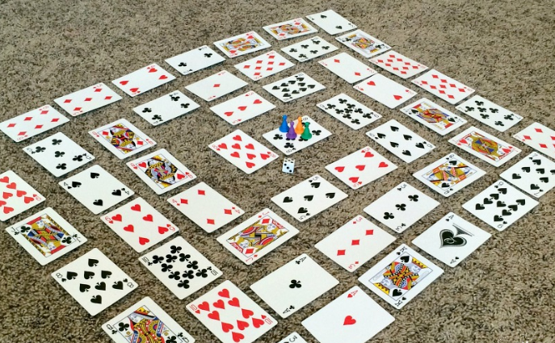

Number Equations
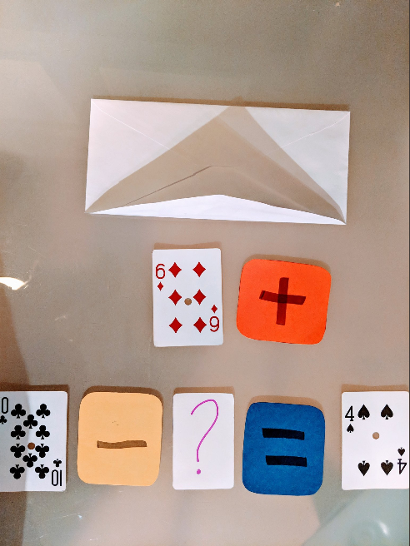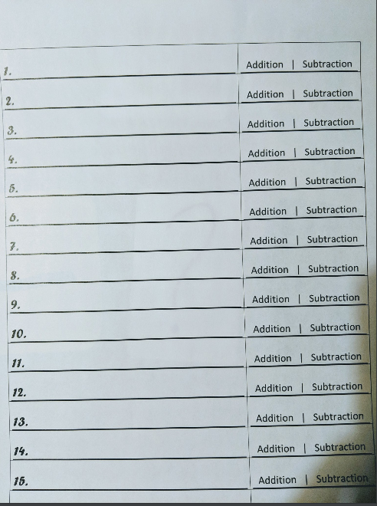
Jennifer Plosz
No. of Children: 1 or more
Cards Required/Resources: Deck of Cards, + - = ? cards, and 3 playing cards which form a number equation.
Instructions:
- Give children an envelope with the 3 playing cards and + -? = cards inside.
- Ask children to make addition and subtraction equations with their cards.
- Each equation must include a question mark.
- How many can they make? Which ones are addition? Which ones are subtraction?

