Words to help explain spelling choices for the
sound /k/ at the start of a word
see the second page for simpler words
cat | cup | cot | kit | keg
caterpillar | cuddle | cotton | kitten | kettle
candle | current | control | kindle | kelpie
candy | curtain | computer | kiss | ketchup
calendar | customer | conversation | kilo | kestrel
cabbage | cut | cold | kick
camera | curious | compact | kin
Using sorting activities and discussions, encourage the
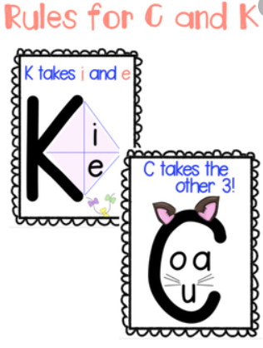
learner to discover which vowel sounds follow the sound /k/
At the start of a word we choose the letter
c to spell the sound/k/ with the vowels a, o and u
k to spell the sound/k/ with the vowels i and e
Words at a simpler level to help explain spelling choices for the
sound /k/ at the start of a word
cat | cup | cot | kit | keg
can | cut | cop | kin | ken
cap | cuff | con | kip | keek

