How to play Race to Read… Spell for Speed!
You need
- A print of the game board given below
- Dice, 1 or 2
- Counters of any kind
- Pencils/ pens and paper, or a whiteboard and pen
Player rolls the dice and moves on the board by that number,
If they land on a grey square they have to read a word that you or another player has written down.
If they land on a green square they have to spell a word that you or another player says to them.
The Words are written on the paper/ whiteboard ( you could use flashcards if you have some they have been working on) and can be taken from their reading book/ topic words/ words in general. Try to stick to words that are within their knowledge, you want there to be a good degree of success if they are to stay motivated!
You can adapt rules to suit yourself – for example a double 6 throw on dice gets an extra turn, if they don’t get the word right they move back a square or back to where they were. Try to keep it fun though and if they make mistakes try giving clues so they can self correct their guess!
Watch out for the hazards on your way around the course.

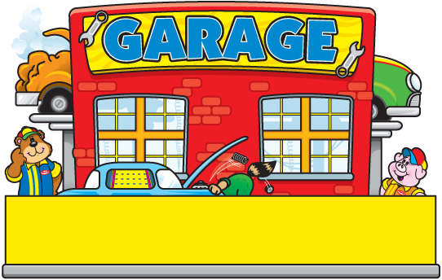

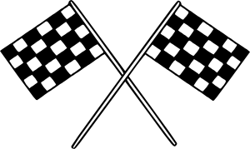
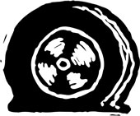

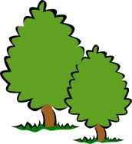
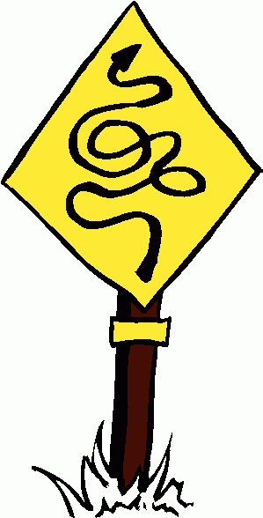
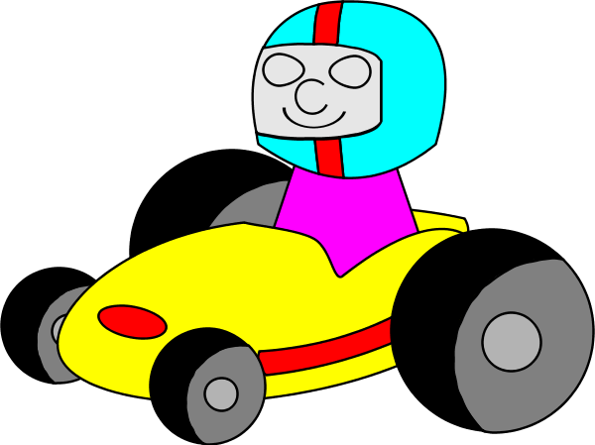
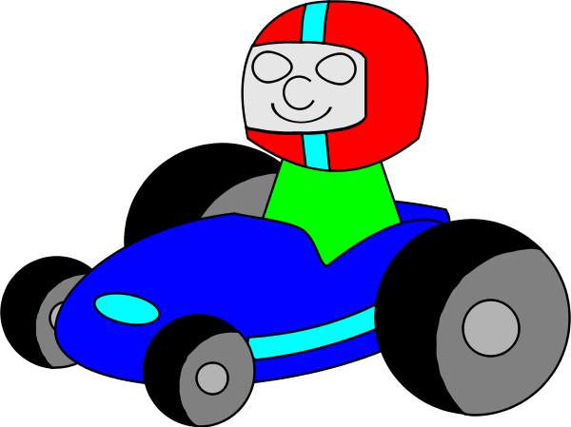
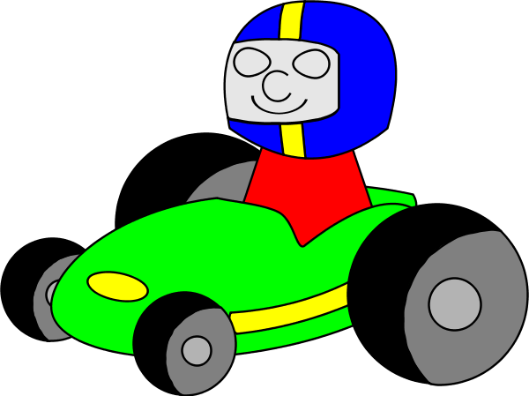
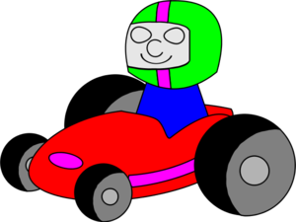
Miss a turn.

smash
Go back to garage.
Miss a turn.
Stop for red light.
Miss a turn.
Read the word.
Write/spell the word.


Roll the dice, move on and if you land on …

