Playing with Stories

Read Together
Developing Talking and Listening skills
And Rhyme Awareness



Read Together

Find a comfortable place to sit and read with your child.

Talk about the title, picture on the front / back cover and ask your child to think about what the book might be about.

Read the story aloud to the child.

Use different voices for the characters in the story.

Ask questions about the story which will help them to understand the story. Use these question words -


What? Where? Who? Why? How? When?

e.g. Where does the story take place?

Encourage child/children to ask you questions about the story.

Chat Together

The ideas below can be applied to any book to develop listening skills.
It is important to increase your children’s vocabulary by introducing new words.
Ask your child to make noises relevant to the story such as animal noises.
In rhyming books, ask your child to say a word which rhymes with a word in the story.
Go for a ‘sound walk’ and take an appropriate book: for example – A book about the park and then listen for various noises.
Birds singing, dogs barking, children shouting, a river flowing, ice cream jingles, bees buzzing etc

- Why not make up some actions together?

It is important that your child can discriminate between similar sounds as they will be doing this when they learn phonics. They need to be able to hear the difference between similar phonemes such as /p/ and /d/
Play a listening game where your child has to distinguish between different sounds behind a screen or curtain. Use things you already have in the house that make a noise, such as shaking pasta in a jar.
or use any musical instruments

Recommended Books for developing Listening skills
Higgly Hen AxelScheffler
P… Pig AxelScheffler
Usborne Peep inside the Zoo Simona Dimitri

Any book is suitable for developing listening and talking skills

Chat Together

The ideas below can be applied to any book to introduce rhyme.

Practise singing/saying nursery rhymes

- sing Row, row, row your boat
- sing 1,2,3,4,5 once I caught a fish alive
- say nursery rhymes e.g. Jack and Jill, Humpty Dumpty
- Say nursery rhymes in funny voices i.e scary voice, baby voice, monster voice or tiny mouse voice.

Play ‘I hear with my little ear’ something that rhymes with sun (bun, fun, gun, run)

Read the stories often with your child and begin to miss out a rhyming word e.g. Twinkle twinkle little star, how I wonder what you _________

Make mistakes when reading nursery rhymes and rhyming stories and let your child catch you out e.g.
Jack and Jill went up the road

Next bath time why not sing ‘Five Little Ducks’ with rubber ducks?
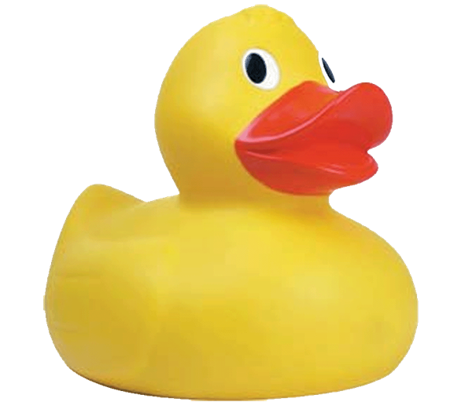

Recommended Books for Rhyme

Each Peach Pear Plum Janet and Allan Ahlberg
Duck in a Truck Jez Alborough
A Squash and a Squeeze Julia Donaldson
The Gruffalo Julia Donaldson
Room on the Broom Julia Donaldson
A Dragon in a Wagon Lynley Dodd
There was a Wee Lassie Kate McLelland
Who Swallowed a Midgie

Recommended websites:

Get Ready to Read:

Play Talk Read: http://playtalkread.scot/

Read Write Count: http://www.readwritecount.scot/

Words For Life: www.wordsforlife.org.uk

Scottish Book Trust: www.scottishtrust.com/bookbug

British Council Website: www.learnenglishkids.britishcouncil.org

National Literacy Trust: www.literacytrust.org.uk/talk_to_your_baby

