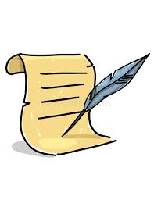
1 2
who which
chin thin
quit quilt
chess chest
quiz thank
when whisk
thin chin
chunk shift
shut 1 2 thump
thud quench
quest think
whip chunk
shift shelf
whiff thing
quilt shock
shell quick
whim shunt
chug quest
quill whisk
that chick
quick thumb
whip champ

Speed Challenge
What’s the time for 'ch’, ‘sh', ‘th', ‘wh' & ‘qu' challenge?

Time |  | Time
 | 1st
 | 2nd
 | 3rd

