Word Matching Activity
Nurse
Doctor
Paramedic
Care worker
Policewoman
Fire man
Bin man
Taxi Driver
Shop keeper
Bus Driver
Teacher
Postman
K
E
Y
W
O
R
K
E
R
S
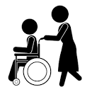
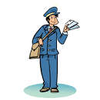
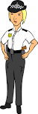
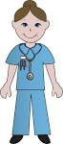
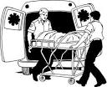
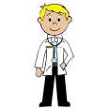
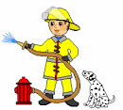
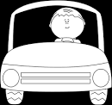
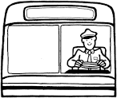
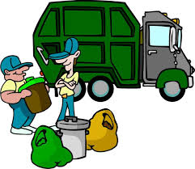
Pictures from http://clipart-library.com/ Free Images

Key workers vocabulary in first language
K
Words in English Words in Urdu
Nurse
Doctor
Paramedic
Care worker
Policewoman
Fire man
Bin man
Taxi Driver
Shop keeper
Bus Driver
Teacher
Postman
E
نرس
ڈاکٹر یا طبیب
طبعی مدد کرنے والا
دیکھ بھال کرنے والا
پولیس والا
آگ بجھانے والا
کچرا اٹھانے والا
ٹیکسی چلانے والا
دوکان دار
بس ڈرائیور
اُستاد یا اُستانی
ڈاکیا

Y
W
O
R
K
E
R
S

Keyworkers jobs and objects matching Activity
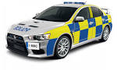
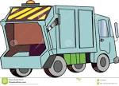
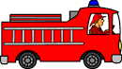
Nurse
Doctor
Surgeon
Care worker
Policeman
Fire man
Bin man
Taxi Driver
Bus Driver
Teacher
Postman

K
E
Y
W
O
R
K
E
R
S
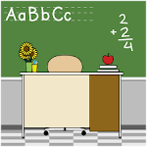
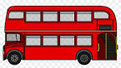
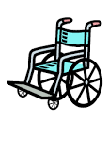
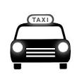
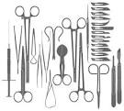

Pictures from http://clipart-library.com/ Free Images

Keyworkers jobs and objects matching Activity
K
E
Y
W
O
R
K
E
R
S
Write Words in your Language

Object | English
 | Fire Engine
 | Police Car
 | Bins
 | Taxi
 | Wheelchair

Pictures from http://clipart-library.com/ Free Images
Keyworkers jobs and objects matching Activity
K
E
Y
W
O
R
K
E
R
S
Write Words in your Language

Object | English | Urdu
 | Fire Engine | آگ بجھانے والی گاڑی
 | Police Car | پولیس کی گاڑی
 | Bins | کوڑے دان
 | Taxi | ٹیکسی
 | Wheelchair | پہیوں والی کرسی

Pictures from http://clipart-library.com/ Free Images

Keyworkers jobs and objects matching Activity
Write words in your own language
Object | English
 | Stethoscope
 | Bin Lorry
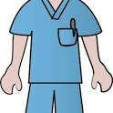 | Nurse’s uniform
 | Teacher’s Desk
Pictures from http://clipart-library.com/ Free Images

Keyworkers jobs and objects matching Activity
Write words in your own language
Object | English | Urdu
 | Stethoscope | سٹیتھو سکوپ
 | Bin Lorry | کچرا اٹھانے والی گاڑی
 | Nurse’s uniform | نرس کی وردی
 | Teacher’s Desk | استاد کا ڈیسک
Pictures from http://clipart-library.com/ Free Images

Job Matching Statement
Nurse
Doctor
Paramedic
Care worker
Policewoman
Fire man
Bin man
Taxi Driver
Shop keeper
Bus Driver
Teacher
Postman
Helping People to take the household rubbish away
Helping people to get better when they are sick
Looking after sick people in the hospital
Delivering mail and online shopping
Selling food and clothes
Driving people around the city in a bus
Helping people if they have a fire or another emergency
Giving emergency help to sick people in the house
Helping people who are not able to live independently
Helping people to stay safe
Driving people to different places in a taxi
Helping children to learn new things

I am a Doctor

I work in a Doctor’s clinic or in a hospital.

When people are ill, I help them to get better.

I try to find out what is making people ill?

I use Stethoscope for the check-up.

I can give them medicine to get better.

Sometimes I send people for an X-Ray or a scan.

Pictures from http://clipart-library.com/ Free Images

I am a Nurse

I work in a Doctor’s clinic or in a hospital.

I help people to get better when they are ill.

I can check patient’s blood pressure and their temperature.

I help people to take their medicine and injections.

I write people’s health chart to keep a record

Pictures from http://clipart-library.com/ Free Images

I am a Paramedic
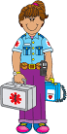

I help people in a medical emergency.

People call me if they have an accident or feeling extremely sick.

I visit people in their homes with a medical kit.

My job is to assess patients and give emergency treatment.

I usually carry medicines and treatment equipment in a bag.

I sometimes call for an ambulance and send patient to the hospital.

Pictures from http://clipart-library.com/ Free Images

I am a Care Worker

My job is to help people in their homes, in a care home or in hospitals.

Sometimes I help people to go out for walks on a wheelchair.

Sometimes I help old people in a care home with their daily routines.

Sometimes I help people in a hospital to go from one place to another place.

Sometimes I help people with a disability to do their shopping and housework.

Pictures from http://clipart-library.com/ Free Images

I am a police officer

My job is to protect people and their property.

Usually I go around in a police car or a police motorbike.

Sometimes, I work in a police station.

Sometimes, I work in a community place such as a school.

I might visit people in their homes in an emergency.

I can also arrest people who are breaking the law.

http://clipart-library.com/ Free Images

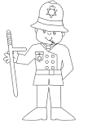
K
E

Y
W
O
R
K
E
R
S

I am a firefighter

K
My job is to help people in many emergency situations.

I usually work in a fire station and go around in a fire engine.

I help people if there is a fire in their house.

I also help in rescuing people and pets in difficult situations.

I sometimes visit schools to teach children about the fire safety.

E
Y
W
O
R
K
E
R
S

Pictures from http://clipart-library.com/ Free Images

I am a Bin Man

My job is to collect waste from around the city.

People can leave their waste for recycling in different coloured bins.

My job is to collect waste from outside people’s houses and take it to the waste dump or a recycling centre.

I go around the city in a garbage truck.

I am helping people by keeping their homes and the streets clean.
K
E
Y
W
O
R
K
E
R
S

Pictures from http://clipart-library.com/ Free Images
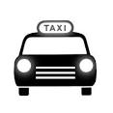
I am a Taxi Driver

My Job is to drive a Taxi.

I pick up passengers in a Taxi and drive them to their destinations.

Sometimes I drive in a black Taxi.

People phone for a Taxi when they are travelling to a bus or a train station or an airport.

There are many Taxi stands around the city.

K
E
Y
W
O
R
K
E
R
S

Pictures from http://clipart-library.com/ Free Images

I am a Shop Keeper
K

My Job is to work in a small shop or in a Supermarket.

I serve people on the counter when they are paying for their shopping.

I also arrange and display different Items on shelves.

Sometimes I help shoppers to find items around the shop.

There are different types of shops such as a News agent or a Greengrocer.

E
Y
W
O
R
K
E
R
S

Pictures from http://clipart-library.com/ Free Images

I am a Bus Driver

My Job is to transport passengers to different places.

I pick up passengers from bus stops around the city.

I collect bus fare from passengers or check their bus tickets and travel cards.

I also give information to passengers about the bus routes.

K
E
Y
W
O
R
K
E
R
S

I am a Teacher
K
E

My Job is to provide education for pupils.

Teachers can work in a nursery or in a primary and secondary schools.

With my help, pupils learn to read and write.

I can also help pupils in learning other subjects such as Art and music and Science.

I also teach pupils about different cultures and religions.

Y
W
O
R
K
E
R
S

Pictures from http://clipart-library.com/ Free Images

I am a postal worker

My job is to deliver letters, parcels and cards to businesses and homes.

I also collect letters from a letter box or from a local post office.

For delivering post, I walk many miles each day.

Sometimes, I drive in a postal van.

K
E
Y
W
O
R
K
E
R
S

Pictures from http://clipart-library.com/ Free Images

Design your Own Key Worker! For EAL Pupils (Urdu)
اپنے کی ورکر کی تصویر بنائیں
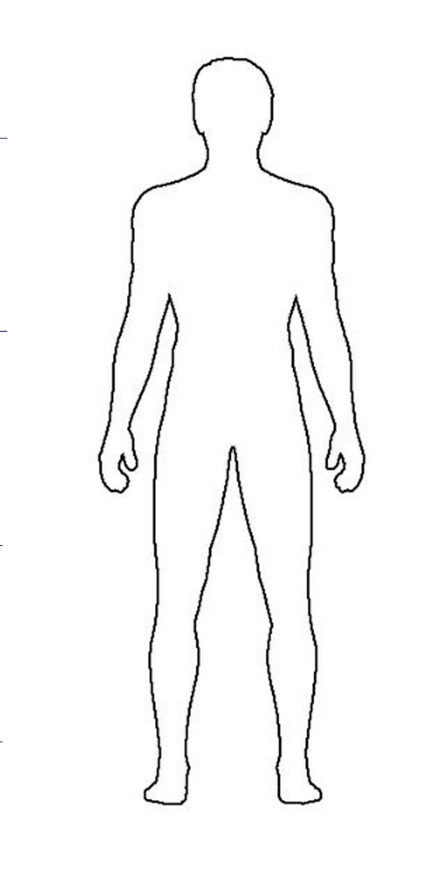
Draw what a keyworker in your area looks like and use the blank lines to describe what they do!
اپنے کی ورکر کی تصویر بنائیں اور اُس کے بارے میں لکھیں
Police Officer پولیس آفیسر
Wears a police uniform پولیس کی وردی پہننا Keep us safe ہماری خفاظت کرنا

Drives a police car پولیس کی گاڑی چلانا Arresting Criminals مجرم کو گرفتار کرنا

Drives a motor bike موٹر بائیک چلانا Helping in emergency مصیبت میں مدد کرنا

Work in a police station پولیس سٹیشن میں کام Giving information سوالوں کے جواب دینا

